# CS 255 System Design Document Template

## UML Diagrams

### UML Use Case Diagram

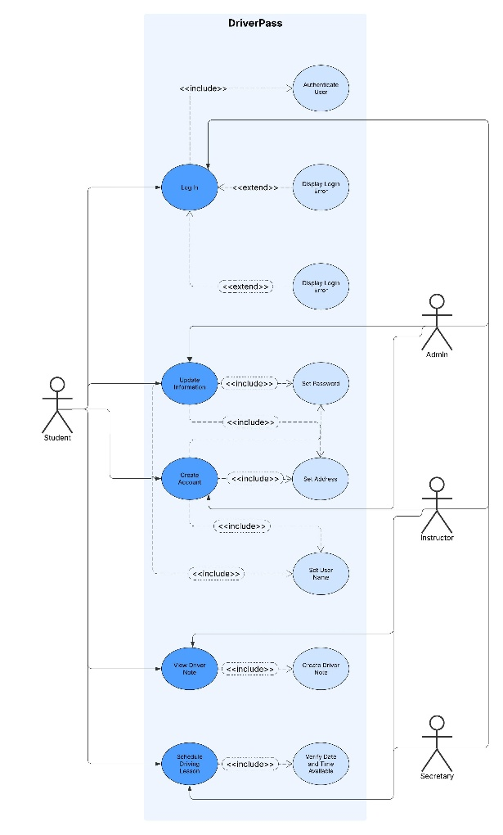

### UML Activity Diagrams

### UML Sequence Diagram

### UML Class Diagram

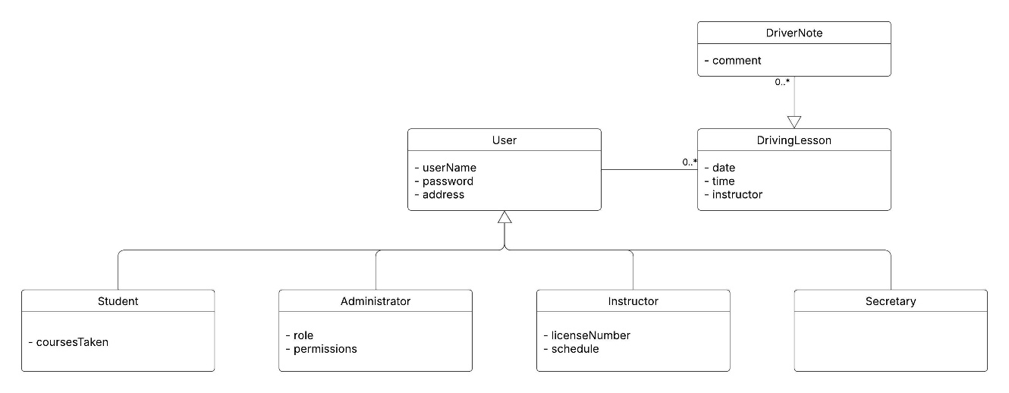

## Technical Requirements

Due to the company’s size being small, the system will utilize cloud infrastructure either AWS or Azure. This will allow the company to scale the size of the system as their business grows and count on the reliability of the providers network. The system will be deployed across multiple different datacenters which will assist in lower latency because the provider will align their usage with the closest physical servers possible. Inside the cloud, Webservers preferable Apache will be used to host the web application. Additionally, SQL servers will need to be maintained to hold users’ data, and course records. This will require the company’s administrators to create company accounts with the cloud provider to deploy the system and manage post deployment, including the integration of third party authentication services that will provide heightened security for the system. The repository will be stored in GitHub and utilize the built-in CI/CD pipelines to maintain constant improvement and minimize downtime as updates are released. The backend logic will be written in Java due to an object-oriented design approach and utilize HTML/CSS on the front end to provide the user with an intuitive user interface.